| Lesson Title | Genetically Modified Organisms |
| --- | --- |
| How many days are needed to teach this lesson? | 3 |
| Grade Level(s) | 9-12 |
| Subject(s) | Math |
| Lesson Summary | Students will examine the relationships between diet, GMOs, and health through the article “[This ‘Super Banana’ Was Designed To Save Lives. Will It Matter That It’s Orange?](https://pulitzercenter.org/stories/super-banana-was-designed-save-lives-will-it-matter-its-orange)”. As students are introduced to the themes presented in this article, they connect their personal diets and possible lack of nutrients to the issues in the article. After reading and discussing, students delve into research to decide “Can a healthy diet contain GMOs?” ending with the creation of an infographic to defend their answer to that claim. |
| Standards | [CCSS.MATH.S-IC.B.6](https://www.thecorestandards.org/Math/Content/HSS/IC/B/6/) Make inferences and justify conclusions from sample surveys, experiments, and observational studies.  [CCSS.MATH.S-MD.B.7](https://www.thecorestandards.org/Math/Content/HSS/MD/B/7/) Use probability to evaluate outcomes of decisions. |
| Focus Pulitzer Center news story/stories | “[This ‘Super Banana’ Was Designed To Save Lives. Will It Matter That It’s Orange?](https://pulitzercenter.org/stories/super-banana-was-designed-save-lives-will-it-matter-its-orange)” by Agostino Petroni for *National Geographic* |
| Additional Resources | [“GMOs, Farm to Table” video from the U.S. Food and Drug Administration](https://www.youtube.com/watch?v=AlqEFfvFtkc)  Article Analysis Task Sheet [[.pdf]](https://pulitzercenter.org/sites/default/files/2025-07/Copy%20of%20Article%20Analysis%20Task%20Sheet.pdf)  Pulitzer Center stations recording document [[.pdf](https://pulitzercenter.org/sites/default/files/2025-07/Pulitzer%20Center%20Stations%20Recording%20Sheet.pdf)][.[docx](https://pulitzercenter.org/sites/default/files/2025-07/Pulitzer%20Center%20Stations%20Recording%20Sheet.docx)]  Stations resources:   * [MyPlate Quiz](https://www.myplate.gov/form/myplate-quiz#question_1) * Guidance from the [National Institute of Diabetes and Digestive Kidney Diseases](https://www.niddk.nih.gov/health-information/weight-management/take-charge-health-guide-teenagers#nutrients) * [GMO Crops in the U.S.](https://www.fda.gov/media/135274/download?attachment), [Where Can You Find GMOs?](https://www.fda.gov/media/160170/download?attachment), [Adoption of Genetically Engineered Crops in the U.S. 1996-2023](https://www.ers.usda.gov/webdocs/charts/108188/GE-Adoption.png?v=5922.2) * [FDA: GMOs: Government Regulation and Your Safety](https://www.youtube.com/watch?v=r541kxAdvI8), [26 Countries Ban GMOs-Why Won't the U.S.?](https://www.thenation.com/article/archive/twenty-six-countries-ban-gmos-why-wont-us/), [Talk About GMOs: Experts Who Know Them and Grow Them](https://www.youtube.com/watch?v=pR2b7lY5F5c)   Rubric for infographic performance task [[.pdf](https://pulitzercenter.org/sites/default/files/2025-08/Copy%20of%20Can%20GMOs%20be%20part%20of%20a%20healthy%20diet_%20Rubric.pdf)][[.docx](https://pulitzercenter.org/sites/default/files/2025-08/Copy%20of%20Can%20GMOs%20be%20part%20of%20a%20healthy%20diet_%20Rubric.docx)] |

# 

# Lesson Plan

| **Lesson Objective(s) or Essential Question(s)** |
| --- |
| Should GMOs be banned from our food supply? |
| **Focus Pulitzer Center News Story/Stories** |
| “[This ‘Super Banana’ Was Designed To Save Lives. Will It Matter That It’s Orange?](https://pulitzercenter.org/stories/super-banana-was-designed-save-lives-will-it-matter-its-orange)” by Agostino Petroni for *National Geographic* |
| **Introducing the Lesson** |
| This lesson allows students to engage with reporting about a health issue in Uganda while allowing them to connect to their personal lives. It asks students to investigate healthy diets, nutrients, and GMOs to develop their ideas about the issue at hand before defending their claims using statistics via an infographic. |
| **Warm-up/Opening** |
| Students complete a gallery walk to answer the following questions:   1. What is a healthy diet for teens? 2. What foods are in your diet regularly? 3. Where do you get your food? 4. What nutrients should you get from your food? 5. How is your diet related to your health?   Display each question on a chart paper or board, and have students write their responses on the posters. After students respond, engage the class in a discussion about each question. Optional: Invite students to discuss in small groups and then share a summary with the class. Then, engage the students in a discussion identifying trends in what came up in small groups. |
| **Preparing to Engage with the Focus Resource(s)** |
| Students will be introduced to GMOs through the brief [YouTube video](https://www.youtube.com/watch?v=AlqEFfvFtkc), [“GMOs, Farm to Table,”](https://www.youtube.com/watch?v=AlqEFfvFtkc)  from the US Food and Drug Administration. |
| **Exploring the Resource(s)** |
| As students read the article, they will complete an article analysis graphic organizer [[.pdf]](https://pulitzercenter.org/sites/default/files/2025-07/Copy%20of%20Article%20Analysis%20Task%20Sheet.pdf) including spaces for new vocabulary words, places to look at on the map, connections to self, and space to write down their thoughts to the following questions:   1. What is special about the “super banana” and why is it important in Uganda? 2. What solutions have been tried to combat the issue and why have they failed? 3. Why has the “Super Banana” not been allowed to be distributed to people in Uganda? 4. What is your interpretation of the following quote at the end of the article? “Culture is dynamic. Otherwise, we would continue writing on stones.” |
| **Processing the Resource(s)** |
| After reading the article, the teacher will facilitate a discussion using the following questions:   1. How do you feel about the idea of “super bananas”? Would you eat them? Do you think this is a good solution? 2. How would you feel about GMOS in your food that would increase nutrients? Do you think that is a better solution than having access to more foods with those nutrients in communities? 3. If you were to create a GMO that would introduce a healthier diet to your day or community, what nutrient(s) would you focus on?   On day 2, after reading and analyzing the article, students will rotate through five stations to deepen their understanding of the themes from the article. They will record their responses to questions in the Pulitzer Center stations recording document [[.pdf](https://pulitzercenter.org/sites/default/files/2025-07/Pulitzer%20Center%20Stations%20Recording%20Sheet.pdf)][.[docx](https://pulitzercenter.org/sites/default/files/2025-07/Pulitzer%20Center%20Stations%20Recording%20Sheet.docx)].   1. “What nutrients may be missing from my diet?”    1. Students will take the [MyPlate Quiz](https://www.myplate.gov/form/myplate-quiz#question_1) from the U.S. Department of Agriculture to see what food groups may be missing from their diet. They will then use the guidance from the [National Institute of Diabetes and Digestive Kidney Diseases](https://www.niddk.nih.gov/health-information/weight-management/take-charge-health-guide-teenagers#nutrients) to identify possible missing nutrients in their diet. 2. “How are GMOs used in the U.S.?”    1. Students will look through resources ([GMO Crops in the U.S.](https://www.fda.gov/media/135274/download?attachment), [Where Can You Find GMOs?](https://www.fda.gov/media/160170/download?attachment), [Adoption of Genetically Engineered Crops in the U.S. 1996-2023](https://www.ers.usda.gov/webdocs/charts/108188/GE-Adoption.png?v=5922.2)) to analyze statistics on the use of GMOs in American food sources. 3. “How many countries grow GM crops?”    1. Students will use resources (“[Where GMO Crops are Grown](https://geneticliteracyproject.org/wp-content/uploads/2021/01/Where-GMO-Crops-Are-Grown-GLP-Infographic_2024Update.pdf), [Public Perception of GMOs](https://www.pewresearch.org/short-reads/2020/11/11/many-publics-around-world-doubt-safety-of-genetically-modified-foods/)” from geneticliteracyproject.org) to analyze global GMO availability and find and process statistics. 4. “To GMO or Not to GMO”    1. Students will use resources ([FDA: GMOs: Government Regulation and Your Safety](https://www.youtube.com/watch?v=r541kxAdvI8), [26 Countries Ban GMOs-Why Won't the U.S.?](https://www.thenation.com/article/archive/twenty-six-countries-ban-gmos-why-wont-us/), [Talk About GMOs: Experts Who Know Them and Grow Them](https://www.youtube.com/watch?v=pR2b7lY5F5c)) to find arguments to support both sides of the GMO debate. 5. “Create a GMO”    1. Students will review their notes and confer with their group to decide on a GMO-enhanced food or crop they would add to their diet and explain why, beginning to answer the question, “Can a healthy diet include GMOs?” |
| **Performance Task** |
| Students will use their notes from their analyses to develop an infographic to defend their answer to the question, “Can Genetically Modified Organisms be part of a healthy diet?” including statistics from their research in stations. |
| **Assessment** |
| Students will be assessed formatively via analysis of the discussion, graphic organizers, and exit tickets. Students’ performance tasks will be assessed via a rubric [[.pdf](https://pulitzercenter.org/sites/default/files/2025-08/Copy%20of%20Can%20GMOs%20be%20part%20of%20a%20healthy%20diet_%20Rubric.pdf)][[.docx](https://pulitzercenter.org/sites/default/files/2025-08/Copy%20of%20Can%20GMOs%20be%20part%20of%20a%20healthy%20diet_%20Rubric.docx)]as a summative assessment. |

Fellow’s Closing Reflection

Proposed Headline: How Chicago Students answered the question, “Can GMOs be part of a healthy diet?”

Author: Shanna Pierce, high school math educator in Chicago, IL and Fall 2024 Teacher Fellow

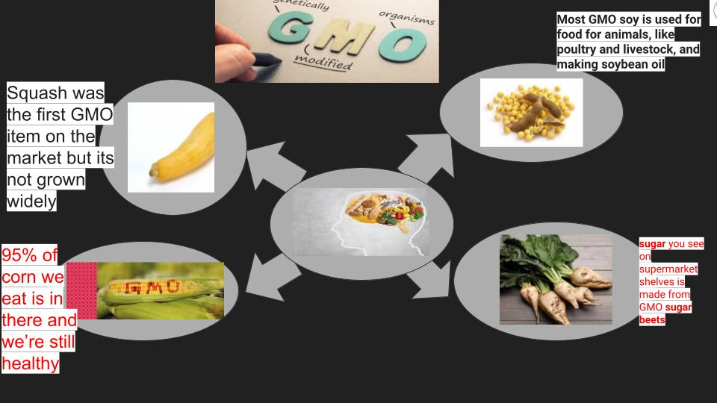

Infographic created by Chicago, IL students after engaging with the lesson, “Genetically Modified Organisms” by Pulitzer Center teacher fellow Shanna Pierce in fall 2024. United States, 2024.

**Shanna Pierce** teaches math to high school students in Chicago, IL. Pierce created the lesson plan “Genetically Modified Foods” as part of the fall 2024 Pulitzer Center Teacher fellowship, Making Local Connections to Global Health Stories.” *Click here to view her full lesson.* At the conclusion of the fellowship, Pierce shared the following reflections on her experience developing and teaching the lesson.

**Tell us about your fellowship lesson: What did you write, and why did you write this lesson for your community?**

This lesson focuses on students answering the question, “Can GMOs be part of a healthy diet?” The lesson begins with students making connections to the food in their own lives before a brief introduction to genetically modified organisms. Students then engage with the reporting in “[This ‘Super Banana’ Was Designed To Save Lives. Will It Matter That It’s Orange?](https://pulitzercenter.org/stories/super-banana-was-designed-save-lives-will-it-matter-its-orange) by Agostino Petroni for *National Geographic* and complete the [Article Analysis Sheet](https://pulitzercenter.org/sites/default/files/2025-07/Copy%20of%20Article%20Analysis%20Task%20Sheet.pdf) I created. Next, students started to dig into different aspects of GMOs and nutrition through five stations. There, students explored their own diets, examined research on GMOs in the U.S., investigated the use of GMOs in other countries, developed their own opinion of GMOs supported by data, and though about what GMOs could help a teenager’s diet. I decided to write this lesson as nutrition has been something I speak with my students’ about regularly because of the foods I see them consuming. This lesson allowed students to explore their own nutritional needs while empathizing with the plight of others across the globe.

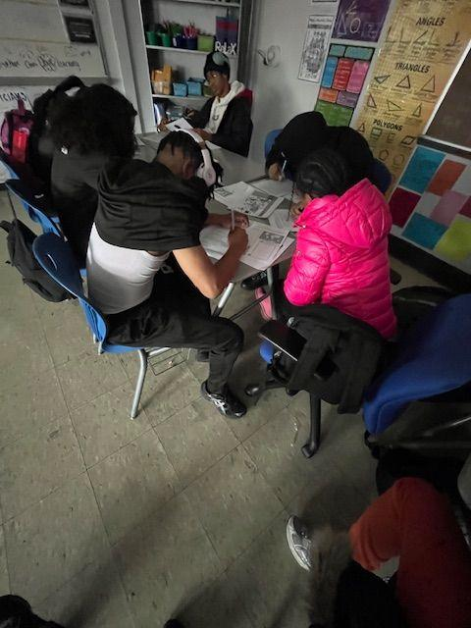

Students in Chicago, IL use a graphic organizer created by their teacher Shanna Pierce to analyze the Pulitzer Center-supported article, “[This ‘Super Banana’ Was Designed To Save Lives. Will It Matter That It’s Orange?](https://pulitzercenter.org/stories/super-banana-was-designed-save-lives-will-it-matter-its-orange) by Agostino Petroni for *National Geographic.* Image by Shanna Pierce. United States, 2025.

**Tell us about you, your students, and your community. How did you build this lesson with your community in mind?**

My students and I are located in a major city far removed from farming and food production. 99% of students in our school qualify for free or reduced lunch. Many of my students come from neighborhoods that would be considered “food deserts” and are regularly getting food from gas stations and convenience stores. Because of this, I knew my students would need some front loading of information about food sources and genetically modified organisms. I also understood that students were going to need graphic organizers to ensure they could record their thinking throughout the lesson to refer back to. As many of my students struggle with reading and are unfamiliar with the topic, I provided some built-in scaffolding to assist with new vocabulary and places.

**Tell us about what your students learned while engaging with the lesson**

Students analyzed graphs, compiled statistics, and used resources to develop a claim that answers the question of this lesson, “Can GMOs be part of a healthy diet?” Students demonstrated their learning through discussion, analysis and answering questions before creating infographics. One connection that several of my students made to the article was attending a funeral at a young age. This got me thinking about the epidemic of gun violence in our city and how that could relate to this article. Students also noticed the ways that the article parallels that very different health issue in that solutions that have been tried thus far have not been successful in our city. They also pointed out that like the government in Uganda, the U.S. government has blocked some measures that could assist with the issue.

**Tell us about what you learned by creating and teaching this lesson: What were your takeaways from this experience? What advice do you have for other educators who may want to engage with your lesson plan and/or the themes in your lesson?**

After implementing this lesson, I have come up with even more ways to analyze this piece of reporting and make connections to the students in my classroom. I feel more confident in looking for and bringing in more articles to the math classroom and finding ways to creatively align my content with the analysis of reporting. For other teachers interested in engaging with the lesson, I would advise that students have experience creating infographics before beginning this short lesson series. I also would encourage teachers to make their own connections to their students. This lesson is adaptable to different possibilities that may relate more to your students. Teachers should be open to the possibility of this lesson and discussion to build organically and be ready to adjust to follow where it goes.

As part of the fall 2024 fellowship, “Making Local Connections to Global Health Stories,” 14 educators from nine states created and taught lessons to engage their over 1,500 students in making local connections to global health news stories*.* [*Click here to learn more about the fellows and their collective impact.*](https://pulitzercenter.org/blog/teacher-fellows-engage-over-1500-students-projects-inspired-global-health-reporting)